[문제] ShuttlePuzzle (말 옮기기 게임)

Hal Burch
Examine the form the sample output gives:
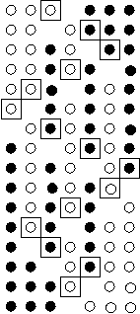

The black squares that outline the moved marble in the sample solution form a pattern:
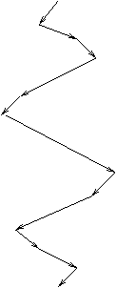
There are two parts of the pattern, the expanding portion and the contracting portion. The boundary of the movement expands by one each pass in the expanding portion, and contracts by one each pass in the contracting portion. In each pass, the selection moves two until it reaches the other end of the boundary, and then goes moves to the new boundary. This pattern can be calculated and outputted to produce the optimal answer.
Since each step can be computing in constant time, this algorithm should run easily within time.
#include <stdio.h>

#define MAXS 32

int size; /* `size' of board, in terms of number of black marbles */
int bsize; /* real size of board, in terms of holes */
int eloc; /* location of empty hole */

FILE *fout, *fin;

void outmove(int i)
{
static int mcnt = 0;
if (i == -1) /* possible newline needed at the end */
{
if (mcnt) fprintf (fout, "\n");
return;
}

eloc = i;
fprintf (fout, "%i", i+1); /* output the answer */
/* handle spacing and newlines */
if (++mcnt < 20) fprintf (fout, " ");
else
{
fprintf (fout, "\n");
mcnt = 0;
}
}

int main(int argc, char **argv)
{
int lv, lv2;

if ((fin = fopen("shuttle.in", "r")) == NULL)
{
perror ("fopen fin");
exit(1);
}
if ((fout = fopen("shuttle.out", "w")) == NULL)
{
perror ("fopen fout");
exit(1);
}

fscanf (fin, "%d", &size);

eloc = size;
bsize = 2*size+1;

/* expansion phase of pattern */
for (lv = 0; lv <= size; lv++)
{
if (lv % 2 == 0) /* even moves left */
{
for (lv2 = 0; lv2 < lv; lv2++)
outmove(eloc-2);
/* expand by one step */
if (eloc-1 >= 0) outmove(eloc-1);
} else { /* odd moves right */
for (lv2 = 0; lv2 < lv; lv2++)
outmove(eloc+2);
/* expand by one step */
if (eloc+1 < bsize) outmove(eloc+1);
}
}

/* contraction phase of pattern */
for (lv = size-1; lv >= 0; lv--)
{
if (eloc < size) /* if eloc is to left of center, move right */
{
outmove(eloc+1); /* contract by one step */
for (lv2 = 0; lv2 < lv; lv2++)
outmove(eloc+2);
} else { /* if eloc is to the right of center, move left */
outmove(eloc-1); /* contract by one step */
for (lv2 = 0; lv2 < lv; lv2++)
outmove(eloc-2);
}
}
outmove(-1); /* clean-up newlines */
return 0;
}

